First

[www.amazon.com](http://www.amazon.com)

1.Internal link : 3

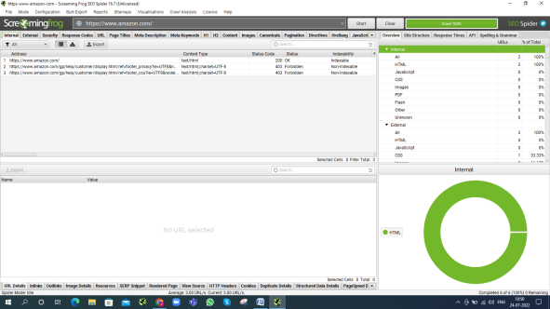

2. External link: 3

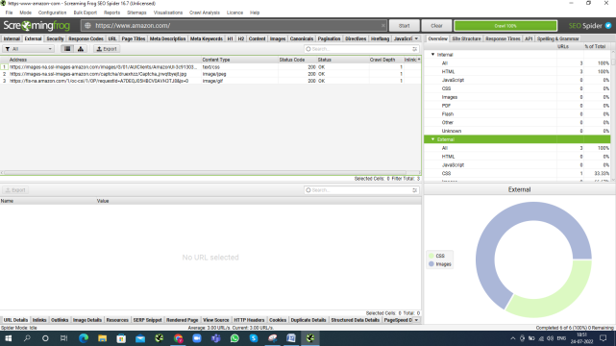

3. Non-ASCII character : 0

4. Under score(_) : 2

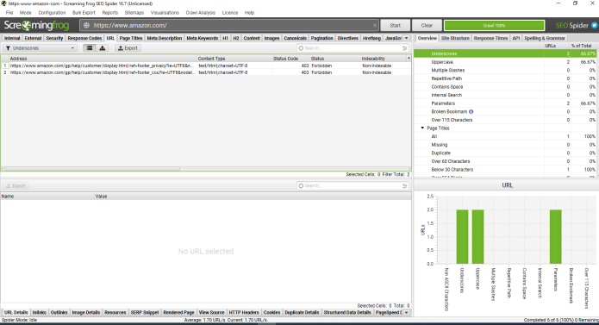

5. Uppercase in URL : 2

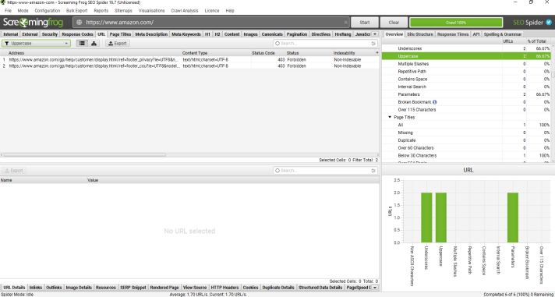

6. Multiple slash: 0

7.Over 115 character : 0

8. Page title : 1

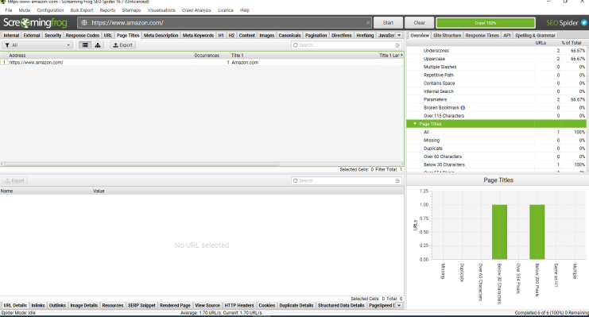

Page title missing: 0

Second

[www.meesho.com](http://www.meesho.com)

1. Internal link : 432

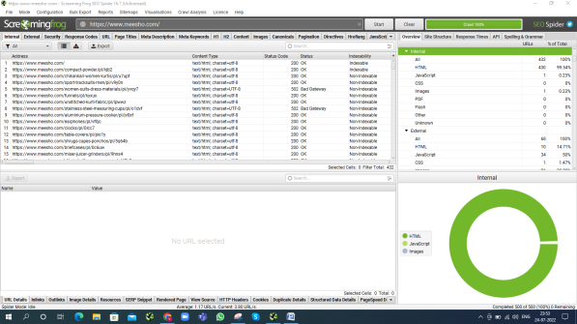

1. External link : 68

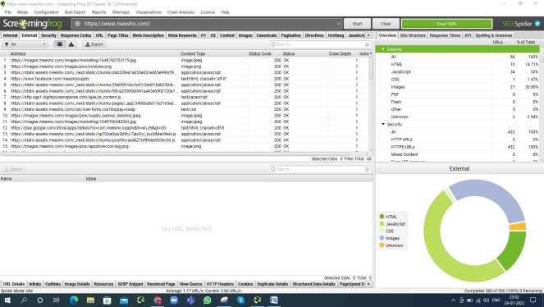

1. Non-ASCII character in URL : 0
2. Underscore in URL : 1

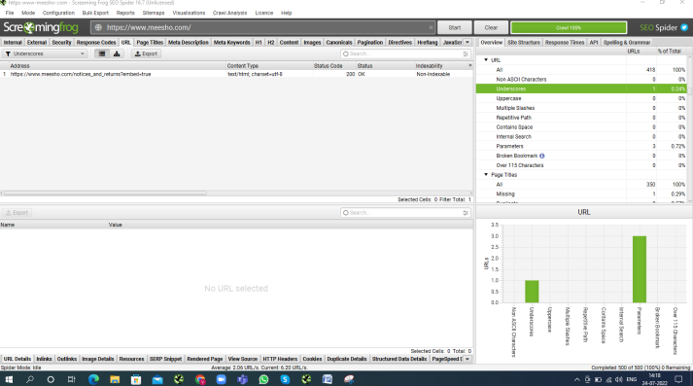

1. Uppercase in URL : 0
2. Multiple slash : 0
3. Over 115 character in URL : 0
4. Page title : 334

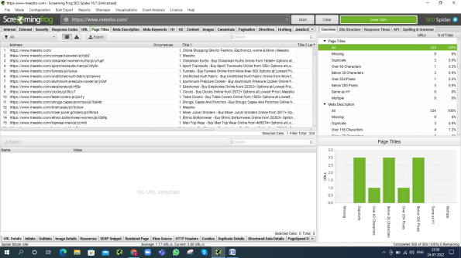

Missing : 1

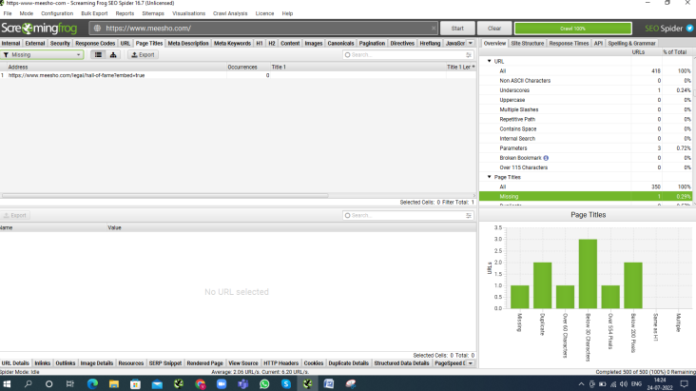

Third

[www.flipkart.com](http://www.flipkart.com)

1. Internal link : 399

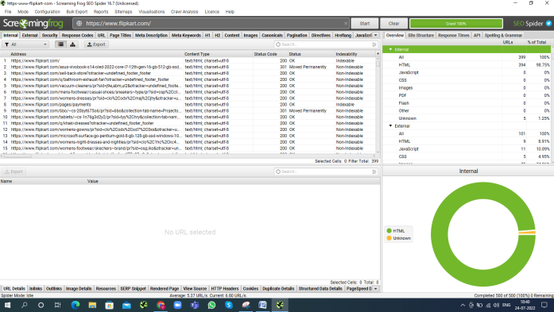

1. External link : 101

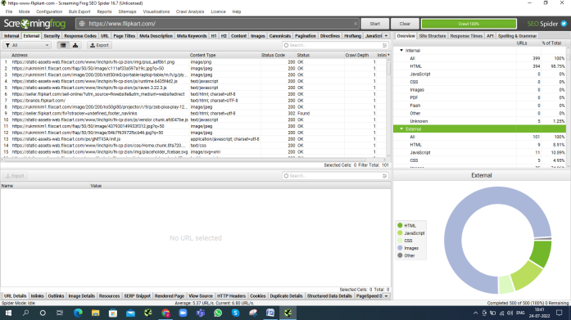

1. Non-ascii character : 0
2. Underscore : 363

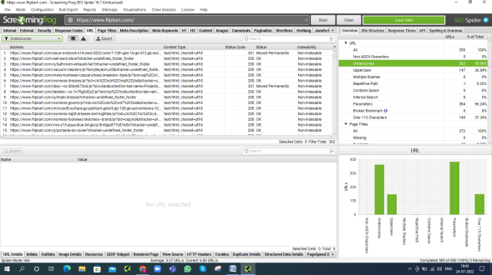

1. Uppercase : 147

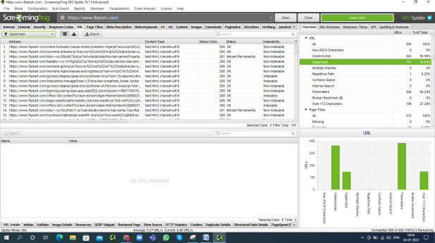

1. Multiple slash : 0
2. Over 115 character in URL : 149

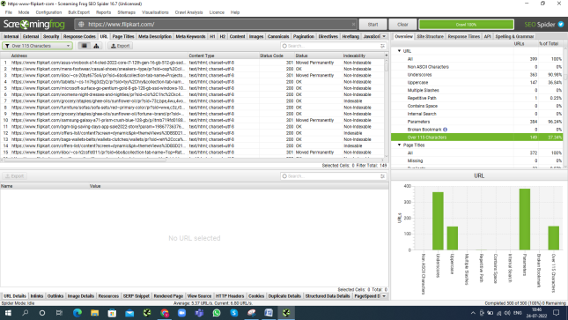

1. Page title : 372

Missing : 0

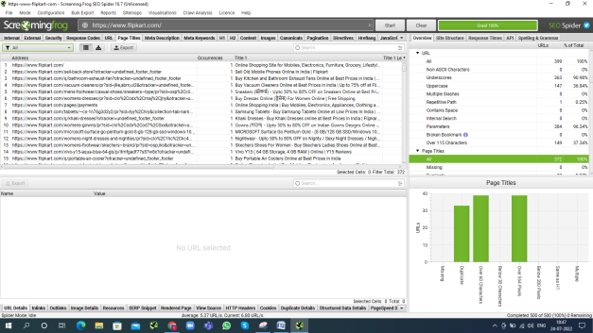

forth

[www.myntra.com](http://www.myntra.com)

1. Internal link : 486

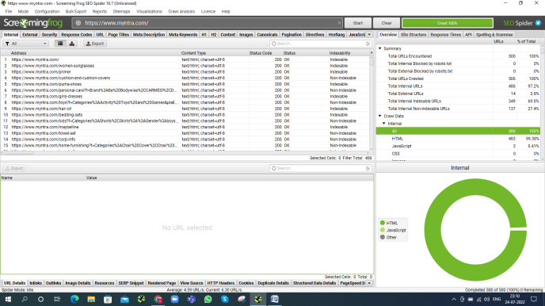

1. External link : 14

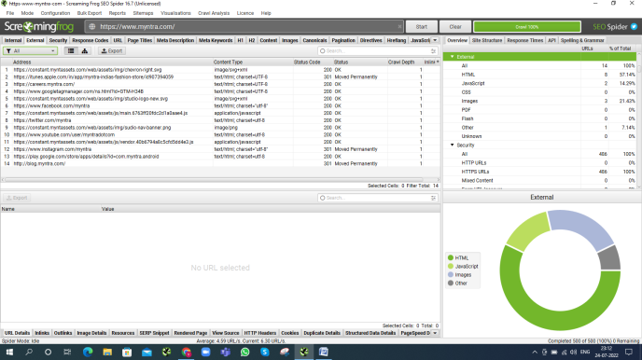

1. Non-ascii character: 0
2. Underscores in URL : 1

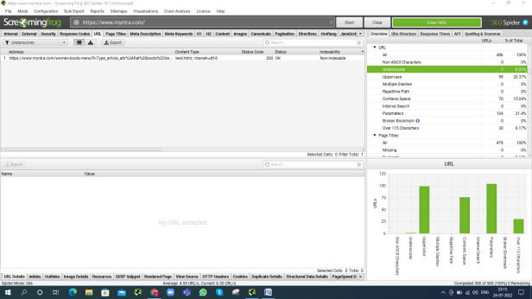

5.Uppercase in URL : 99

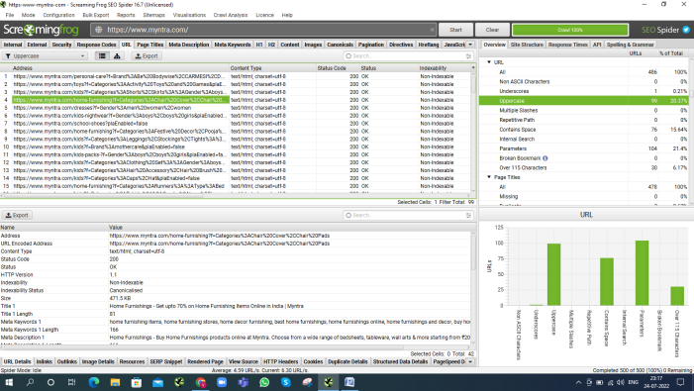

1. Multiple slash : 0
2. Over 115 character in URL : 30

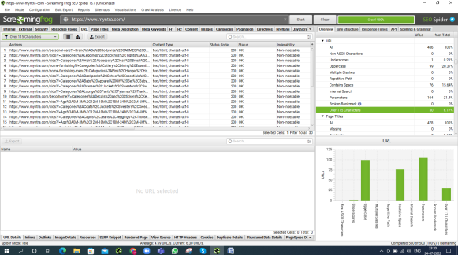

1. Page title : 478

Missing : 0

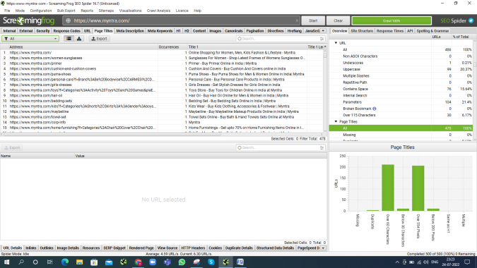

fifth

[www.angelone.com](http://www.angelone.com)

1. Internal link : 11

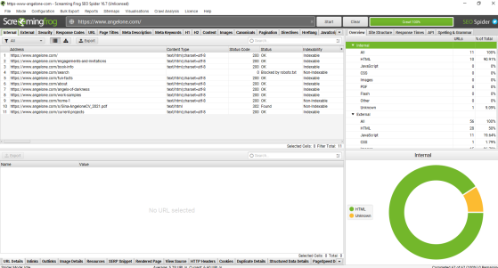

1. External link: 56

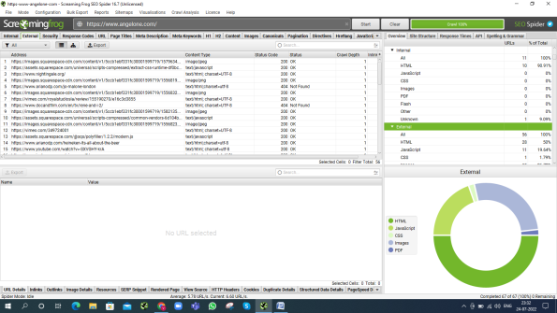

1. Non-ascii character in URL : 0
2. Underscores in URL : 1

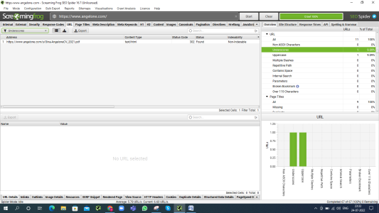

1. Uppercase in URL : 1

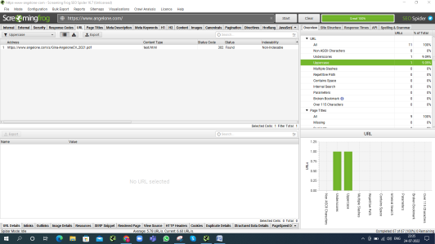

1. Multiple slashes in URL: 0
2. Over 115 character in URL : 0
3. Page title : 9

Missing : 0

